Optional Homework 2
Rohan Krishnamurthi
10/28/2024

Useful code:
- Project directory: /projects/e31265/rsk9305/optional_2
- Cancel all jobs: scancel -u rsk9305

- Download FastQ files corresponding to samples SRR6357070 and SRR6357081.

Load SRA toolkit in Quest:
module load sratoolkit

Download relevant files:
prefetch SRR6357070 downloads folder of one SRA file
fastq-dump --outdir . --gzip SRR6357070/SRR6357070.sra --split-3

prefetch SRR6357081
fastq-dump --outdir . –gzip SRR6357081/SRR6357081.sra --split-3

- For each sample, align the reads using STAR to create one BAM file for each sample.

Obtain Reference genome
mkdir ensembl
cp /projects/e31265/ensembl/* ensembl/

Build an index: run opt_2.1.sh
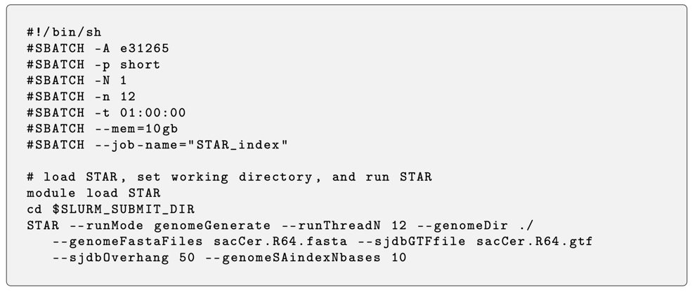
*Change the 50 to 100 (100 base pairs)
Align reads to the reference genome

Bash scripts: opt_2.2.sh, opt_2.3.sh
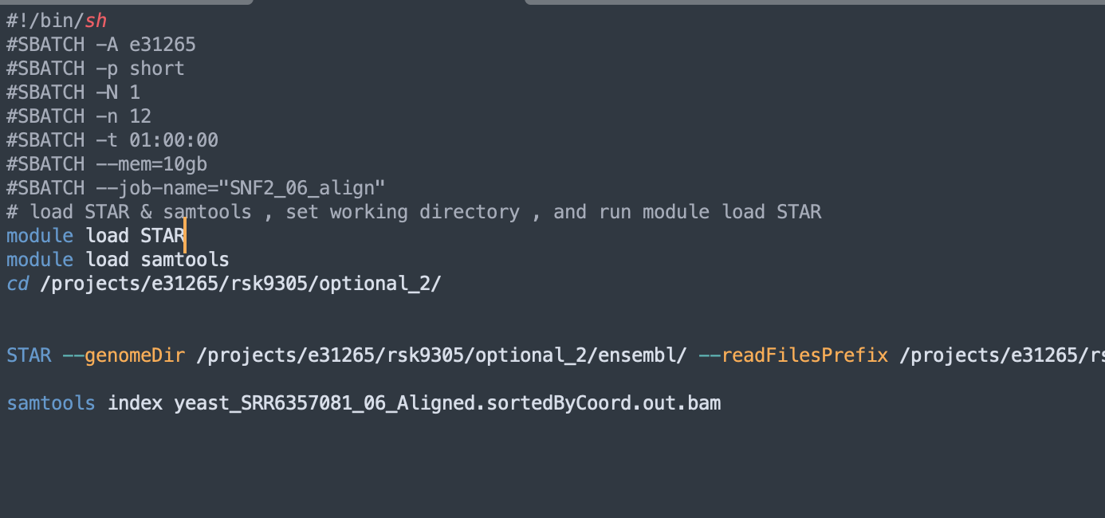

70: complete
81: complete

- Run Multiqc

Module load multiqc
Multiqc .

Output name: multiqc_report_2.html
Sample 70 aligned reads: about 48 million
Sample 80 aligned reads: about 48 million

- RSeQC analysis

Install RSeQC
module load mamba
mamba create --name rseqc python=3.7
mamba activate rseqc
mamba install -c bioconda -c conda-forge rseqc

OR: conda install bioconda

In ensemble folder:
module load perl
perl /projects/e31265/bin/gtf2bed.pl sacCer.R64.gtf > sacCer.R64.bed12

Infer Experiment:
infer_experiment.py -r /projects/e31265/rsk9305/optional_2/ensembl/sacCer.R64.bed12 -i aligned_reads

infer_experiment.py -r /projects/e31265/rsk9305/optional_2/ensembl/sacCer.R64.bed12 -i yeast_SRR6357070_Aligned.sortedByCoord.out.bam

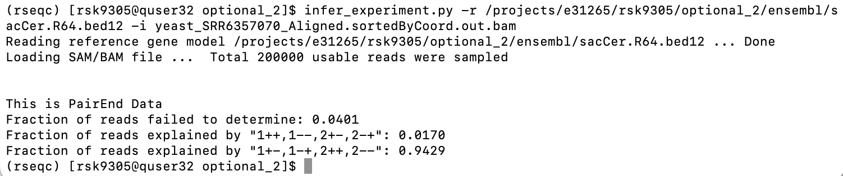

infer_experiment.py -r /projects/e31265/rsk9305/optional_2/ensembl/sacCer.R64.bed12 -i yeast_SRR6357081_Aligned.sortedByCoord.out.bam
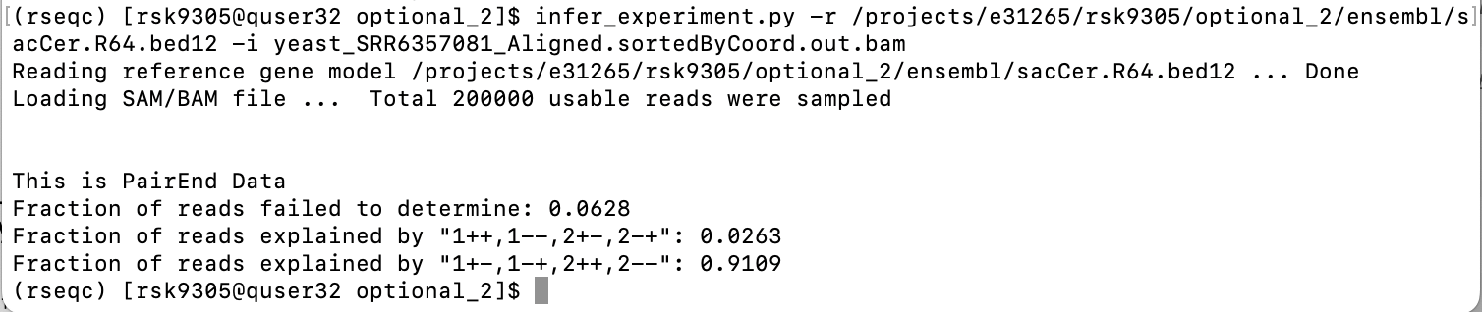

Inner distance:
inner_distance.py -r /projects/e31265/rsk9305/optional_2/ensembl/sacCer.R64.bed12 -i file.bam -o output

inner_distance.py -r /projects/e31265/rsk9305/optional_2/ensembl/sacCer.R64.bed12 -i yeast_SRR6357070_Aligned.sortedByCoord.out.bam -o SRR6357070

inner_distance.py -r /projects/e31265/rsk9305/optional_2/ensembl/sacCer.R64.bed12 -i yeast_SRR6357081_Aligned.sortedByCoord.out.bam -o SRR6357081

- View BAM files in IGV

Gene locations: PHO89, URA1, COS1

PHO89:

URA1:
COS1:

